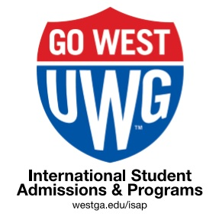

February 2021 Newsletter
Published monthly by International Student Admissions and Programs (ISAP) to provide reminders about
immigration regulations, services, programs, and opportunities for involvement.

CONTENTS:
- Happy Valentine’s Day
- Tax Season is Here! – Let’s Taco’bout Taxes!
- Enrollment Requirements & UWG Student Code of Conduct
- Reminders
- Employment Workshops
- ISAP Events
- Campus Jobs
- Follow ISAP on Instagram | Contact ISAP

HAPPY VALENTINE’S DAY – FRIDAY FEB. 14th 2021

We are glad you are here and thank you for being part of the UWG family. Drop by ISAP on 2/14 to say hello, get some chocolate and a hug if you need one. You are the world at UWG!
What is this day about anyway? Where did it come from? Is it just an American marketing stunt?
Check out this 2:32 minute History Channel Video.

TAX SEASON 2021 (FOR TAX YEAR 2020)| FILING DEADLINE: APRIL 15, 2020
If you 1st arrived in the U.S. in 2020, RELAX - you don’t have anything to file or do this year regarding taxes.

Everybody Else: You need to understand the basic flow chart below.
The #1 Question from International Students!
Q: I’m not a U.S. citizen, so why do I need to do this?
A: The US government might owe you a refund. If you don’t ask for it, you won’t get it. If you ever apply for a future visa or a Green Card, all tax records will be required for every year. Filing the proper tax form each year is the law for everyone in the U.S., regardless of income or employment.

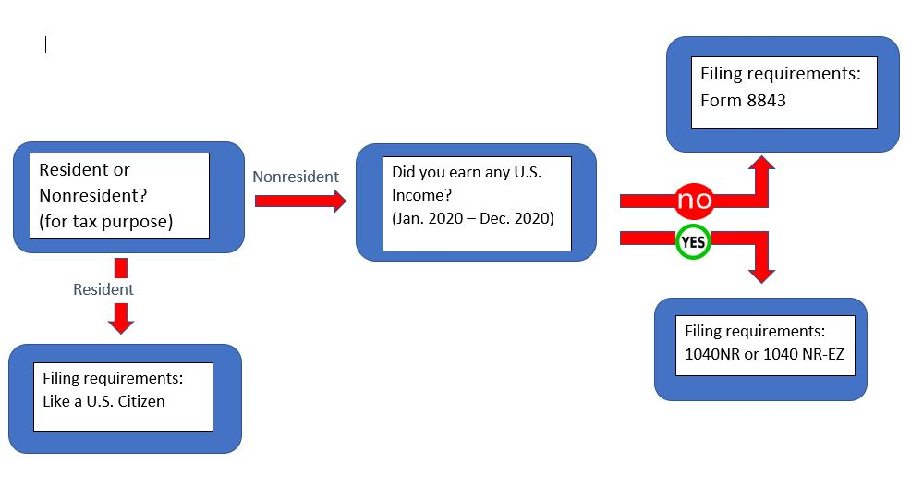
Another way to understand this is:
- Were you in the US in 2020 with income or a scholarship?
>> Prepare a complete non-resident tax return on form 1040-NR-EZ. Use Sprintax!

- Were you in the U.S. in 2020 with NO income or scholarship?
>> Only complete form 8843. It’s a simple form. We can help.

- Have you been in the U.S. more than 5 calendar years?
>> You might be a Resident for Tax Purposes. Do not use Sprintax. Use the same software or forms as Americans (1040 EZ, not 1040-NR-EZ) *NR = non-resident
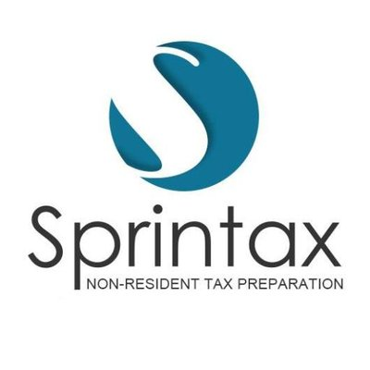
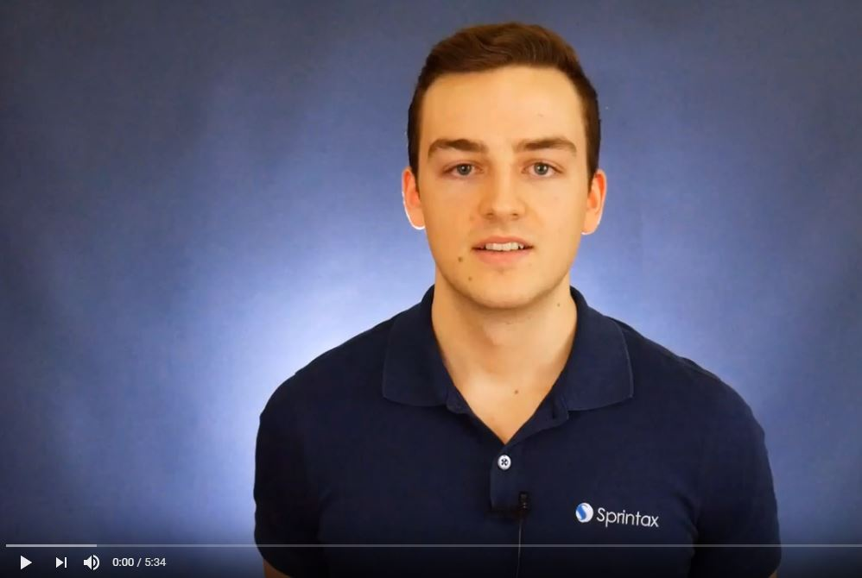
1: Click the photo to watch a 5 minute intro video from Sprintax.
2: Review the ISAP tax information page.
3: If you had taxable income in 2020, ISAP will email a free code in late February to your UWG email. Use it to pay for Sprintax at the end.
4: Print full return or form 8843. Mail it to the IRS. Keep a copy for your records. You’re done!

Be aware: the Sprintax code from ISAP is only for use by UWG international students who are enrolled or on OPT. Sharing the code with anyone else is a basis for termination of your status.

NEED HELP ?
“Let’s Taco Bout Taxes!” – Virtual!
- Friday, March 4th, 11:30 – 1pm in ISAP
- This is our free tax info workshop.
- RSVP to: rashikaw@westga.edu

UWG STUDENT CODE OF CONDUCT >> online here

Please be reminded:
- The legal drinking age in the US is 21 years old.
- If you enter a bar or place that sells alcohol, you will be asked for photo ID ( DL or passport). If you are under the age of 21 you will not be served or allowed to buy alcohol.
- Possession, use or distribution of pot in any form is illegal in Georgia and in the US, despite being legal in some states.
- In Georgia, this is a "misdemeanor" (lower category) crime, with a possible fine of $1000 or a year in jail. O.C.G.A. §16-13-2(b)
- A criminal conviction, including D.W.I. (Driving While Intoxicated) can lead to visa revocation and a 10-year travel ban to the U.S.

We encourage you to think wisely about your choices.

REMINDERS
- FULL-TIME ENROLLMENT. Undergraduate - 12 credit hours. Graduates - 9 credit hours. No exceptions. ISAP will be conducting enrollment checks periodically thought the semester.

MAKE FRIENDS | GET INVOLVED
The best way to meet new people, improve your English and be successful in the U.S. is to make friends. The best way to make American friends is to get involved in a campus organization!
Pick an interest, sign up, show up and say hello! It’s that simple.
- List of 150+ student organization at UWG is HERE
- To sign up, register in “Wolf Connect” HERE

SPRING SEMESTER CAMPUS EMPLOYMENT
- F1 & J1 students may be employed in non-federal work study jobs on campus up to 20hrs per week.
- J1 students must request employment authorization first.
- All employment requires application for a free Social Security Card.
- Instructions for the SSN application are here >> Support & Services
- UWG campus jobs are listed on this webpage >> Jobs at UWG

EMPLOYMENT WORKSHOPS FOR INTERNATIONAL STUDENTS

Before you can work off campus for any reason, you need authorization. Come learn about it at our free free employment workshop: 4 this semester. Sign-up required. Details are here at International Student Employment
So, what is Curricular Practical Training (CPT) or Optional Practical Training (OPT)?
- CPT - Required for paid off-campus internships
- OPT - Required to work in the U.S. after graduation in your degree field.
All Employment Workshops are held in the Mandeville Hall Room 109 1:30 - 2:30pm

Upcoming Workshop Dates: ALL VIRTUAL
- Feb. 9th, 2020 – Curricular Practical Training (CPT)
- Feb. 18th, 2020 – Optional Practical Training (OPT)

To sign up for more details see International Student Employment

EVENTS
Georgia International Leadership Conference (GILC) – Virtual
March 5th – 6th, 2021.

UWG Outdoors
URec Outdoors offers lots of fun, low-cost trips to explore our region! Please see: https://www.westga.edu/campus-life/urec/adventure-trips.php

UWG Athletics
Be sure to check out their games as part of the American University tradition! We recommend catching an exciting basketball game or the volleyball match! All events are free with UWG ID: https://uwgsports.com/
How do I sign up for ISAP events?
You register in “Wolf Connect” HERE. No emails will be accepted as signing up for events.

CONNECT WITH ISAP
- ISAP on IG | Click the Logo
- International Student Admissions & Programs (ISAP) @ UWG
Mandeville Hall | Front Campus Drive
www.westga.edu/isap | T: 678-839-4780
- Email Us
Include your 917 and full name
- NO WALK IN ADVISING|

