Strategic Hiring and Pay Adjustment
Approval Process

Background
The Governor’s Office of Planning and Budget (OPB) has requested all state agencies to institute a strategic hiring approval process for all regular, full-time faculty and staff positions. Please see the attached letter to the USG Presidents from Chancellor Wrigley.
Strategic Hiring/Pay Adjustment & Increases Approval Process:
This process applies to all regular, full-time faculty and staff positions to be filled through the university’s posting process; promoting from within to vacant positions; reclassifying positions to a higher level (pay grade); reclassifying positions resulting in a title change; giving in-range pay adjustments; increasing salary earned and paid through UWG’s payroll process (one-time or ongoing); and interim promotions; regardless of funding source. This applies to additional pays, supplemental pays, etc.–any increase added to a regular, full-time faculty and staff pay regardless if one-time or ongoing (excluding awards approved by USG’s incentive approval process).
This process applies to positions currently in process that have not been posted on UWG’s website or approvals not received prior to December 15, 2019:
1. A Critical Hire/Pay Adjustment form must be completed.
- “A critical hire is considered a position that the institution must fill in order to maintain student success, patient/life safety, and to successfully meet required compliance and accreditation standards. A critical hire is not the same as an important hire. We have many positions within the university system that are important to institutional success, but would not be considered critical.” Refer to USG’s Critical Hire FAQs attached.
- A thorough and strategic justification for the need for the position or pay adjustment must be provided. To fill a position, you must include the impact on the institution if the position is not filled.
- Any supporting data regarding student success, patient/life safety, and compliance or accreditation requirements that must be met should be provided.
- For grant and contract-funded positions, please attach the award letter and documentation that supports the requirements for personnel and the compensation rates that have been agreed to.
- Information to complete the form may be found in the position detail in People Admin to which managers have access or by contacting your HR Business Partner.
  - The Position Title and Classification Title often are different. Please use the “Classification Name” field in PeopleAdmin for the Classification Title and use the “Position Title” field in PeopleAdmin for the Position Title field on the form.
  - The Position Pay Grade may also be found in PeopleAdmin.
- The salary range for the pay grades may be found on HR’s website at: https://www.westga.edu/hr/assets-hrpay/docs/uwg-staff-pay-scale.pdf
- A link for the Employee Id resides in the blue boxes on the bottom of Human Resources’ home page at: https://www.westga.edu/hr/
- Only include one position per form for Administrative and Staff positions over $40,000, including positions with faculty status.
2. All positions must be vacant a minimum of 60 days before they can be permanently filled, unless an exemption is granted by the President. The Critical Hire form should be submitted within the 60-day window.
3. Approvals:
- The unit head (AVP/Dean/Director) needs to approve the form and will submit to the respective Vice President of the division.
- The form will be submitted to the President/Vice President review by the Vice President of the division.
- The request will be reviewed and approved in writing by all Vice Presidents and President, collectively using the new form.
- Filling New or Vacant Staff and Administrative Positions (including those with faculty status) over $40,000: Requires approval of the USG prior to posting or filling.
  - BOR approval applies to staff and administrative positions, including those with faculty status, that are: posting for vacant positions; posting/filling new positions; promoting an existing employee (same as filling a vacant or new position); placing an employee in an interim position (same as filling a new position); or reclassifications that result in a title change or a higher pay grade, with or without an increase in pay (same as filling a new position).
  - Please note the USG office has informed us that only critical positions will be approved, not important positions, while the critical hire process is in effect. Refer to the USG FAQs.
4. Once approvals are obtained, the Critical Hire form will be sent to UWG’s Human Resources for further processing.
- The approved, Critical Hire form must be received in Human Resources prior to any administrative office’s approval (Human Resources, Budget, Data Management, Payroll).
- Posting and recruiting (either internally or externally) any new or vacant administrative/staff positions over $40,000, including those with faculty status, must be approved by the University System of Georgia. See item 3.B above for detail.
  - UWG’s Human Resource department is responsible for submitting the form to the USG.
  - The USG’s web form at https://survey.usg.edu/s3/CHPJT, must be used (no email or other means of submission accepted).
  - All requests received at the USG by the end of the business day each Monday should receive a response (Approve/Denied) from the USG no later than the end of the business day on Friday of the same week.
  - Human Resources (HR) will approve the recruitment or posting of the position only after USG approval is received.
- After HR and USG (if required) approval, the request will be routed via UWG’s normal processes with the Critical Hire form attached or emailed to the subsequent approvers.
5. By the 10th of each month, UWG’s Human Resource department will provide a report to the System Office of all regular, full-time faculty and staff positions hired, promoted, reclassed, etc. with a salary above $40,000. Reports will be emailed to criticalhire@usg.edu .

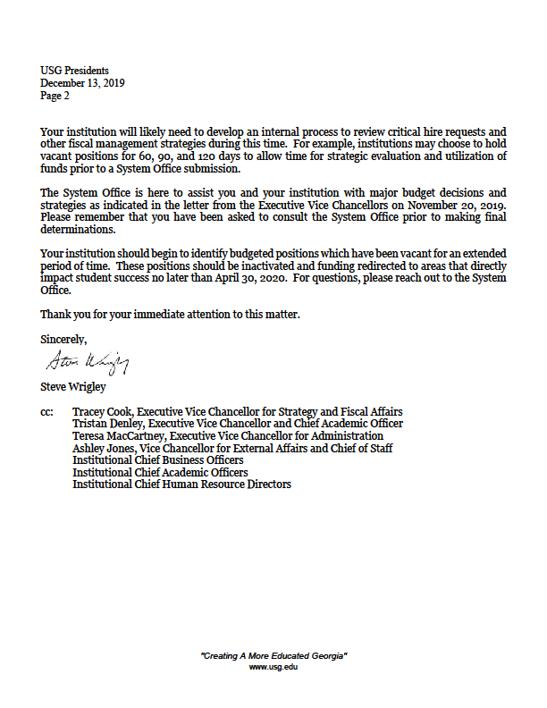

Critical Hire Process FAQs
Last updated December 31, 2019

What is a critical hire?
A critical hire is considered a position that the institution must fill in order to maintain student success, patient/life safety, and to successfully meet required compliance and accreditation standards. A critical hire is not the same as an important hire. We have many positions within the university system that are important to institutional success, but would not be considered critical. Important positions will not be approved while the critical hire process is in effect.
The critical hire process and submission link was shared with CBOs and CHROs via email on December 16, 2019.
Institutions should plan early and start the critical hire process as soon as possible. Critical hire requests can be submitted as soon as an institution is aware of new position or vacancy even if the position will be filled later. Justification forms should provide complete details upon submission in order to expedite the response timeframe.

Why are we doing this?
Governor Kemp asked all state agencies to think strategically about how to improve business processes by eliminating duplication, better utilizing technology, or other methods of efficiency, to include thinking strategically about workforce needs and how to best leverage existing positions and personal services funding. Additionally, the Governor’s Office of Planning and Budget (OPB) asked all state agencies to institute a strategic hire (critical hire) approval process.

What type of documentation will be required for the justification?
The institution should provide a compelling case for critical nature of a position in the critical hire form. Any supporting data regarding student success, patient/life safety, and compliance or accreditation requirements that must be met should be provided. For grant or contract funded positions, an institution should submit the award letter and documentation that supports the requirements for personnel and the compensation rates that have been agreed to.

How long will the critical hire process be in place?
The critical hire process went into effect December 15, 2019 without a defined end date. If and when the process changes, a notification will be sent to the President, Chief Business Officer, and Chief Human Resources Officer.

What positions will be subject to the critical hire process?
As of December 15, 2019, all full-time regular positions, faculty and staff, above $40,000 will be subject to the critical hire process.
A justification form will not be required for positions posted prior to December 15, 2019; however, positions filled December 15, 2019 and after should be reflected on the monthly institution report.

Are grant-funded and contract positions included in the critical hire process?
Yes, the critical hire process is applicable to all fund sources.

Will the use of temporary staff require approval?
No, the critical hire process is only applicable to full-time regular employees. Temporary staffing decisions should follow existing institutional review and approval processes.

If an institution chooses to reclassify an existing position, should a critical hire form be submitted?
No, an institution has the ability to restructure existing roles to find efficiencies and accommodate changes to the workforce. The USG policy on Salary and Wage Administration must be followed if a change in compensation is warranted with the reclassification. We encourage institutions to incorporate reclassification requests into the internal critical hire review process.

Can an institution hold a position to save funds?
Yes, an institution can make the determination to hold a position during the strategic review process or as a fiscal management strategy. When and if the institution determines that they would like to proceed with filling the role, a critical hire form will be required at that time.

Are positions within my institution’s approved CAR plan subject to the critical hire process?
Yes, newly created positions that are included in your institutions approved CAR plan must be submitted for approval through the critical hire process before posting. Any additional changes or consideration given should be included in the justification narrative.

Can campuses continue existing projects that involve position description reviews and compensation equity analysis?
Yes, existing organizational effectiveness and compliance projects may continue. If an institution considers making compensation strategy changes or adjustments, a notification to the University System Office should be provided along with a summary of the proposed activity. This notification may be submitted to criticalhire@usg.edu.

What response will I get from the system office review team?
You will receive a letter with one of two responses: approved or denied. It is the responsibility of the institution to provide adequate justification and documentation for the critical hire as a part of their submission. Please note that the USO review team will not be able to assist a campus with developing their justification statements.

Is there a way to expedite a request?
Institutions should plan early and start the critical hire process as soon as possible. Critical hire requests can be submitted as soon as an institution is aware of new position or vacancy even if the position will be filled later. Justification forms should provide complete details upon submission in order to expedite the response timeframe.
Urgent positions that involve patient/life safety such as medical personnel or public safety officers can be posted immediately on a contingent basis if deemed necessary through this campus critical hire process. A critical hire form should be submitted simultaneously to the USO for approval to continue. If the request is denied, the institution should immediately remove the contingent posting and discontinue the recruitment process. This process is only acceptable for positions that are deemed critical to patient/life safety by the president and CBO.

When is the campus monthly report due?
The campus report of all full-time regular faculty and staff hired during the preceding calendar month will be due by the 10th of the month or closest Monday if the 10th falls on the weekend. The December 2019 report will be due on January 10th for all full-time regular faculty and staff positions with start dates on or after December 15, 2019 above $40,000 annually. Reports should be emailed to criticalhire@usg.edu.

Can the president or Chief Business Officer delegate their signature authority?
Generally speaking the USG submission process requires the approval and signature of both the president and CBO, not a designee. If the president or CBO are away for extended travel and unable to authorize, notification of a designee may be sent to the criticalhire@usg.edu inbox along with the timeframe of designation.

Are electronic signatures acceptable for the president and CBO?
Yes, if routed through a secure process or system such as Docusign. It is expected that the campus process will engage the president and chief business officer directly on requests that proceed to the system office for approval.

Who should I contact with questions?
The critical hire process has an email address that will be monitored by the USO review team. Questions may be submitted to criticalhire@usg.edu.

