University of West Georgia
Office of the Controller
How to View Agency Account Balances & Transactions
Updated 8/26/16

There are multiple ways to obtain balance and transaction information for agency accounts. Below are the instructions for how to use the three different resources you have to choose from.

1) First, you can go to this link: http://uwg-webforms01.uwg.westga.edu/FinReports/FY17/. This web site is maintained by Vince Gibson in IT. The home page of the site appears as follows:

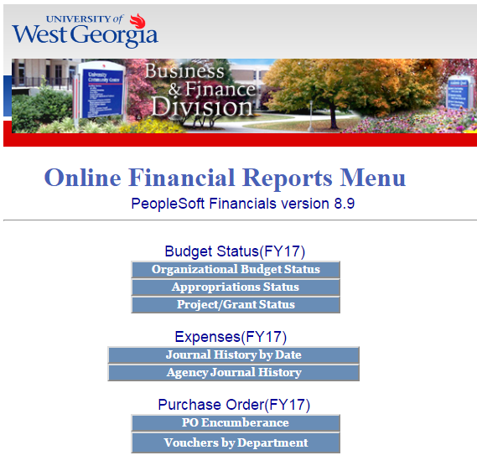
For Agency Account information, click on “Agency Journal History” under the “Expenses(FY17)” section. Your screen should then appear as follows:
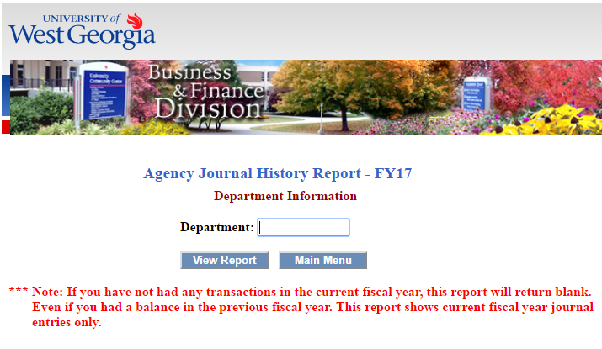

Please notice the note that this report will only produce current fiscal year activity, so it will not give you your cumulative balance. You can pull previous fiscal years’ activity by simply editing the end of the URL above to match the year you need.

*Additional Note Specifically for Study Abroad Accounts: because study abroad accounts have to be closed out each year and re-opened for the new programs (with new accounts), you actually should see your cumulative balance, because the balances in old accounts must be manually moved to the new accounts by accounting personnel in the Controller’s Office. These transfers constitute current year activity. However, this is only the case once the account has gone through all appropriate approvals and account setup and prior balances have been transferred to the new accounts.

2) Secondly, you can view account balances using the Ledger Inquiry Report within PeopleSoft. Log in to PeopleSoft, follow the path illustrated below, and select “Ledger” (Main Menu => General Ledger => Review Financial Information => Ledger).

Enter “LEDGER” for inquiry name (the first time you use this report, you will have to select the “Add a New Value” tab to create the run control – you can use a different name if you want, but it’s best to try to reflect the name of the report as best as possible).

Enter your parameters as follows: (However, change the Department ID to reflect the agency account you want; A600057 is a closed account which was entered as an example. You may also need to change the Fund code; a few agency accounts may use Fund 61000 or 62000.) Note: Agency Department ID’s always start with “A”.

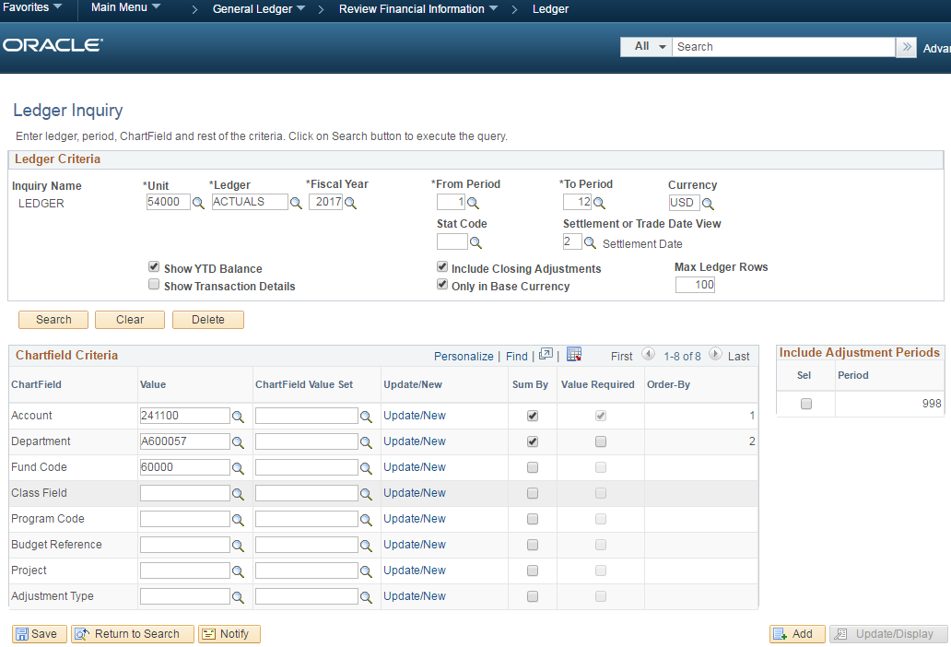

Click “Search.” The result should give you your cumulative balance available shown as the “Posted Total Amount.” (This should be displayed as a negative, or credit, balance. If this number is positive, your account is at a deficit; contact the Controller’s Office immediately).
You can also see this report with detailed transaction information by deselecting “Show YTD Balance” and selecting “Show Transaction Details” in the parameters above. However, this will only produce information for a single month, so it will not give you your cumulative balance.
3) Lastly, and probably most comprehensive, you can use the General Ledger Activity report (also in PeopleSoft). Log in to PeopleSoft, follow the path illustrated below, and select “Ledger Activity” (main Menu => General Ledger => General Reports => Ledger Activity).
Enter “GL_ACTIVITY” for the Run Control ID (again, the first time you use this report, you will have to select the “Add a New Value” tab to create the run control – you can use a different name if you want, but it’s best to try to reflect the name of the report as best as possible).

Enter the parameters as follows (but again change the department ID to the appropriate account):

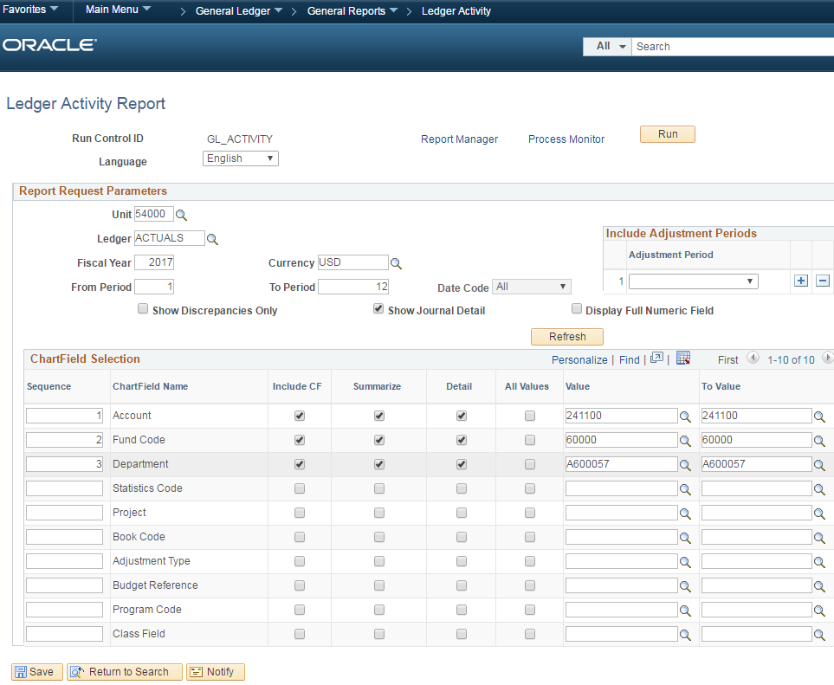

Click “Run,” then “OK” (the best distribution format tends to be PDF, but you have other options if you like), then select your Process Monitor. Once the report has processed to a Run Status of “Success” and a Distribution Status of “Posted,” select Details, then View Log/Trace, then the PDF (or whatever other distribution format you may have chosen). This report will give you all activity that has been posted and it also includes a beginning balance, so your ending balance is your cumulative available balance. Again, this balance should show as a negative (credit), so if it is positive, contact the Controller’s Office immediately.

Please direct any questions regarding this training document to Scott Puckett in the Controller’s Office by email at spuckett@westga.edu or call 678-839-5328.

