- Speaker: Holly Mostrum, Terri Rubino – Human Resources
  - Rate changes, tobacco surcharge, spousal change
  - Q&A – Add town halls to calendar
  - USG – Vendors, policies, open enrollment dates – work arounds for open enrollment dates – spouse enrollments – If your spouse has an offer of insurance from their employer
  - Yes or No – like tobacco – all would encourage to go in and see questions – stopped smoking for at least 3 months before you can select no for tobacco user
  - Will have to certify all people on plan will default
  - DOT – CDL – test for legal version of weed – CBD oil questions – not really a thing yet
  - Leave Pool – policy effective January 1 – BOR – All eligible employees per donation period must have 48 hours to donate 1x year during open enrollment
  - Can donate 8-80 hours – need form – on HR website – max can receive 160 hours per request – Max 480 hours for total – any request to leave pool must have used all personal vacation and sick leave
  - Prorated for employees non-benefited
  - 8 hours each year – always have to reenroll
  - TAP Forms – new – email, no more than 30 days before TAP deadline – just tuition – not fees only taxed on over $5,000
  - Call toll free number – Alight – Oct – Nov extentsion
  - Oct 28 – November 8th power point for Town Hall on USG Website
- Presidential Search Update
  - Email Allyson with questions to ask the candidates
- Officer Reports
  - Help West – Aday Gift – Nichole
  - Give feedback on Engage West Staff Engagement
  - Dec 3rd Toys for Tots – Alumni House – volunteers – drive through – bins from Housing – PR Committee – Bylaws Committee – confusion in Bylaws – add committee requirement
- Committee Breakouts
- Other Business/Questions

In Attendance: Allyson Bretch, Shawn Isaacs, Sarah Powell, Christy Rabern, Juli Humpheries, Wade Crenshaw, Basia Wilas, Embry Ice, Renèt Jones, Nikki Gage, Ashley Swancey, Jennifer McManus, Harriett Holley, Amy Lavender, Tina Skinner Reece, Jessica Renard

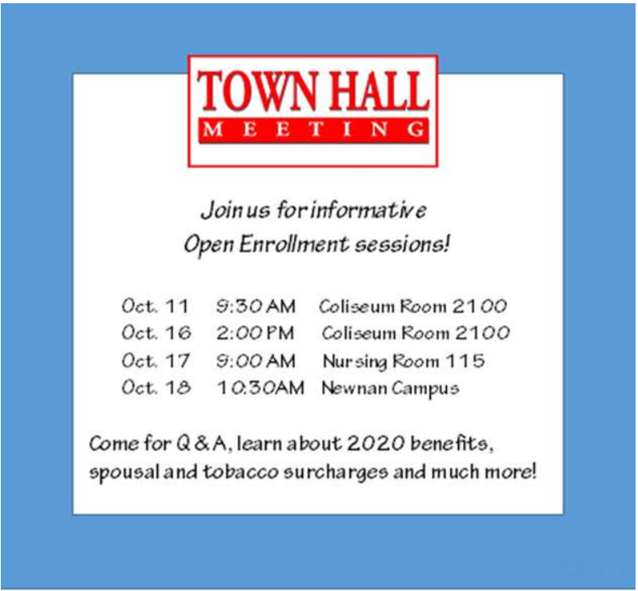

Notes:

NEXT MEETING: November 13, 2019 at 11am, Campus Center 108.3 – Speaker: Kristi Carman – General Counsel

