Main Campus ·
College of Arts and Humanities ·
Art
Demo Course
ART-1000
Fall 2020 Section Demo Section 3 Credits 06/06/2019 to 06/06/2020 Modified 06/16/2020
Course instructors will need to have information for each of the highlighted fields below. This information can be drafted in Microsoft Word and then copied/pasted into Concourse. As a reminder, once this information is in the system on one course, in can then be imported in without having to manually type it.

Description

This section is imported from Banner. This field cannot be edited.

Contact Information

Instructors will need to enter their information here. If the instructor's profile is complete within Concourse, this information can be copied. If not, it will have to be manually entered into each syllabus. Below is a screenshot of the fields that need to be entered here.
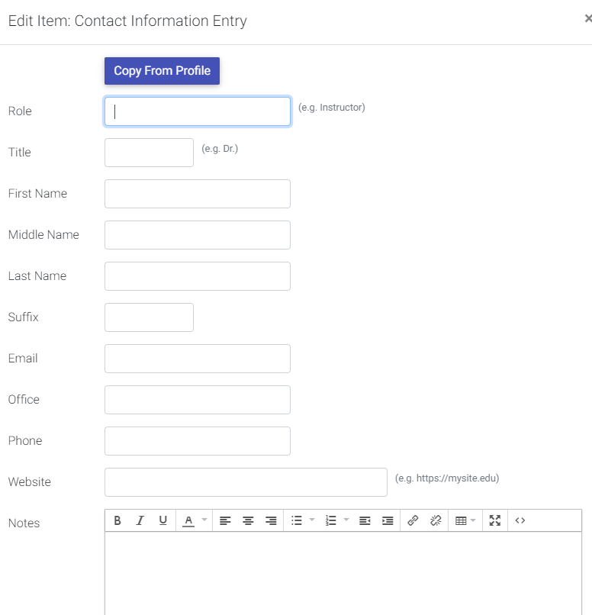

Meeting Times

Instructors will need to enter this information here.

Materials

Instructors will need to enter this information here. Below is a screenshot of the fields that need to be entered here.
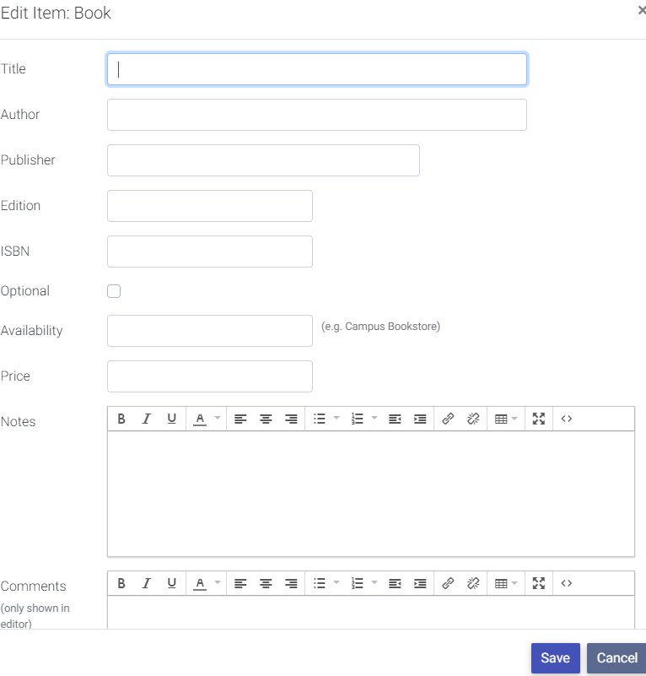

Outcomes

Instructors will need to enter this information here.

Evaluation

Instructors will need to enter this information here.

Assignments

Instructors will need to enter this information here.

Schedule

Instructors will need to enter this information here.

Course Policies and Resources

Instructors will need to enter this information here.

College Policies

This information will be imported from the College/School template associated with your course. This field cannot be edited.

Institutional Policies

This information will be imported from the Institutional template associated with your course. This field cannot be edited.

Academic Support
Accessibility Services: Students with a documented disability may work with UWG Accessibility Services to receive essential services specific to their disability. All entitlements to accommodations are based on documentation and USG Board of Regents standards. If a student needs course adaptations or accommodations because of a disability or chronic illness, or if he/she needs to make special arrangements in case the building must be evacuated, the student should notify his/her instructor in writing and provide a copy of his/her Student Accommodations Report (SAR), which is available only from Accessibility Services. Faculty cannot offer accommodations without timely receipt of the SAR; further, no retroactive accommodations will be given. For more information, please contact Accessibility Services (https://www.westga.edu/student-services/counseling/accessibilityservices.php).
Center for Academic Success: The Center for Academic Success (http://www.westga.edu/cas/) provides services, programs, and opportunities to help all undergraduate students succeed academically. For more information, contact them: 678-839-6280 or cas@westga.edu.
University Writing Center: The University Writing Center (https://www.westga.edu/writing/) assists students with all areas of the writing process. For more information, contact them: 678-839-6513 or writing@westga.edu.

Online Courses
UWG takes students’ privacy concerns seriously: technology-enhanced and partially and fully online courses use sites and entities beyond UWG and students have the right to know the privacy policies of these entities. For more information on privacy and accessibility for the most commonly used sites, as well as technology requirements visit the UWG Online (https://uwgonline.westga.edu/) site.
Students enrolled in online courses can find answers to many of their questions in the Online/Off-Campus Student Guide (http://uwgonline.westga.edu/online-student-guide.php).
If a student is experiencing distress and needs help, please see the resources available at the UWG Cares
(http://www.westga.edu/UWGCares/) site. Online counseling (https://www.westga.edu/student-services/counseling/index.php) is also available for online students.

Honor Code
At the University of West Georgia, we believe that academic and personal integrity are based upon honesty, trust, fairness, respect, and responsibility. Students at West Georgia assume responsibility for upholding the honor code. West Georgia students pledge to refrain from engaging in acts that do not maintain academic and personal integrity. These include, but are not limited to, plagiarism, cheating, fabrication, aid of academic dishonesty, lying, bribery or threats, and stealing.
The University of West Georgia maintains and monitors a confidential Academic Dishonesty Tracking System. This database collects and reports patterns of repeated student violations across all the Colleges, the Ingram Library, and the School of Nursing. Each incidence of academic dishonesty is subject to review and consideration by the instructor, and is subject to a range of academic penalties including, but not limited to, failing the assignment and/or failing the course. Student conduct sanctions range from verbal warning to suspension or expulsion depending on the magnitude of the offense and/or number of offenses.
The incident becomes part of the student’s conduct record at UWG.
Additionally, the student is responsible for safeguarding his/her computer account. The student’s account and network connection are for his/her individual use. A computer account is to be used only by the person to whom it has been issued. The student is responsible for all actions originating through his/her account or network connection. Students must not impersonate others or misrepresent or conceal their identities in electronic messages and actions. For more information on the University of West Georgia Honor Code, please see the Student Handbook (https://www.westga.edu/administration/vpsa/handbook-code-ofconduct.php).

UWG Email Policy
University of West Georgia students are provided a MyUWG e-mail account. The University considers this account to be an official means of communication between the University and the student. The purpose of the official use of the student e-mail account is to provide an effective means of communicating important university related information to UWG students in a timely manner. It is the student’s responsibility to check his or her email.

Credit Hour Policy
The University of West Georgia grants one semester hour of credit for work equivalent to a minimum of one hour (50 minutes) of in-class or other direct faculty instruction AND two hours of student work outside of class per week for approximately fifteen weeks. For each course, the course syllabus will document the amount of in-class (or other direct faculty instruction) and out-ofclass work required to earn the credit hour(s) assigned to the course. Out-of-class work will include all forms of credit-bearing activity, including but not limited to assignments, readings, observations, and musical practice. Where available, the university grants academic credit for students who verify via competency-based testing, that they have accomplished the learning outcomes associated with a course that would normally meet the requirements outlined above (e.g. AP credit, CLEP, and departmental exams).

HB 280 (Campus Carry)
UWG follows University System of Georgia (USG) guidance: http://www.usg.edu/hb280/additional_information# (http://www.usg.edu/hb280/additional_information)
You may also visit our website for help with USG Guidance: https://www.westga.edu/police/campus-carry.php (https://www.westga.edu/police/campus-carry.php)

Mental Health Support
If you or another student find that you are experiencing a mental health issue, free confidential services are available on campus in the Counseling Center. Students who have experienced sexual or domestic violence may receive confidential medical and advocacy services with the Patient Advocates in Health Services. To report a concern anonymously, please go to UWGcares.

Additional Items

Instructors will need to enter this information here, if applicable.

