connectWest Device Setup Instructions for Windows 10 Laptop
1. In order to successfully complete these instructions, your laptop must be on campus and be able to connect to the connectWest wireless network. Also, you must be able to access the wireless network sharing center on your Windows PC.
2. From your wireless network list, select “connectWest” and connect to the network.
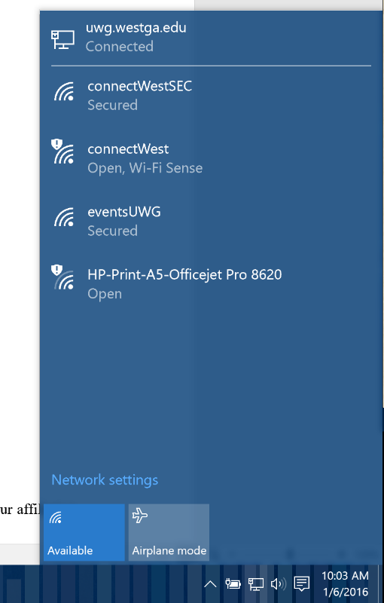

3. After joining this network, open your web browser. A "Welcome" screen will appear prompting you to sign in with your UWG ID and Password. Please enter them now and hit “login”
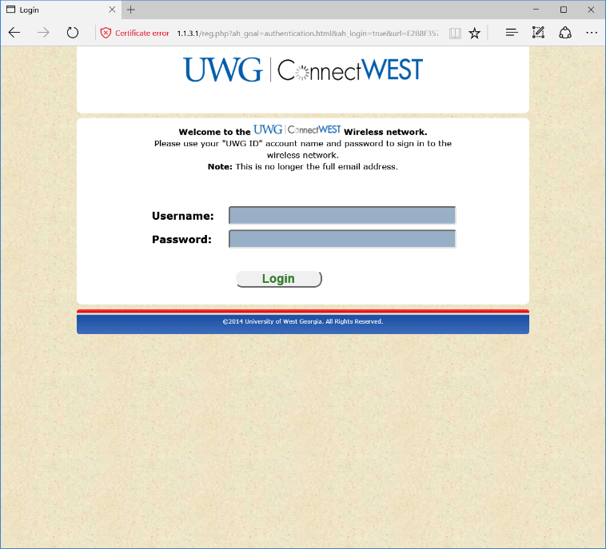
4. Once you are logged in, choose “To Continue to the On-Ramp Services”. Then click “Start” to agree to the terms and agreement and start the on-ramp services.
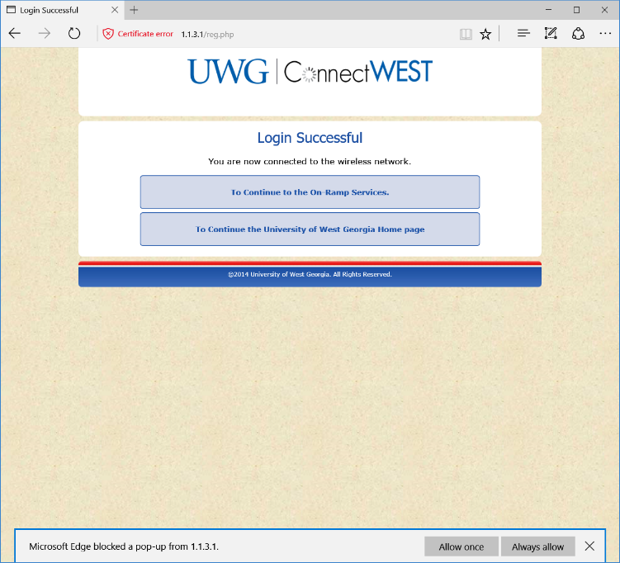
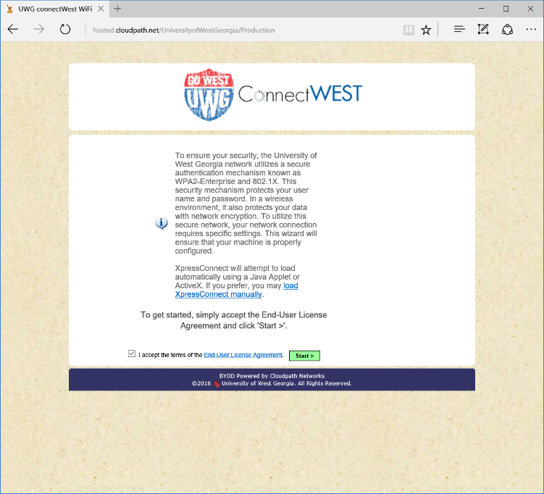

5. On the next page, you will be asked to download the NetworkWizardLoader.exe file to on-ramp onto our UWG wireless network. Click the link to download the program. When it finishes downloading, click “Run” to run it.
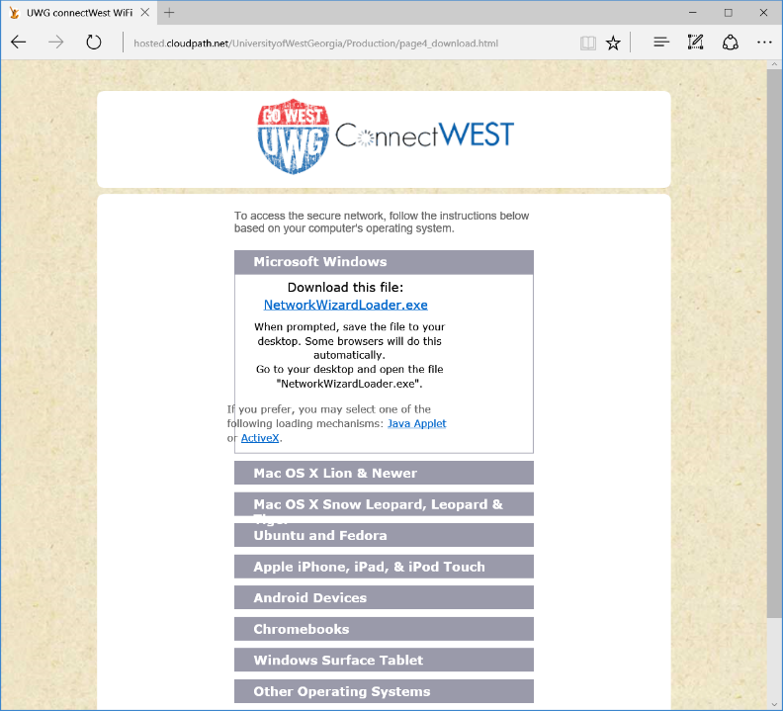
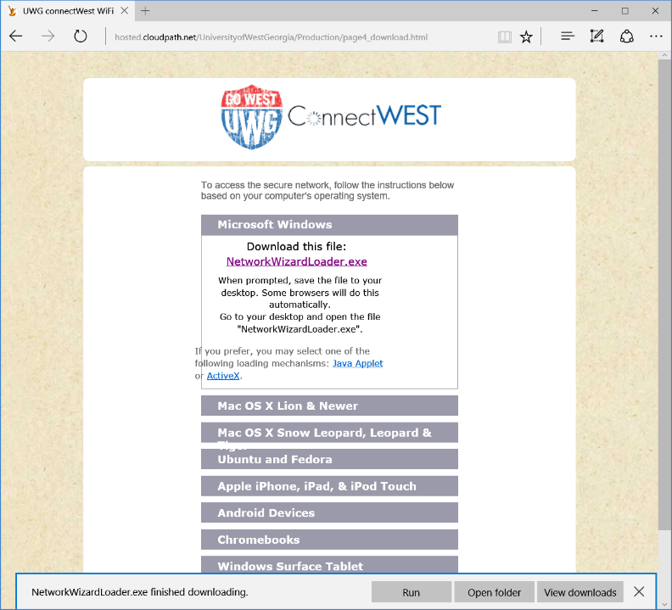

6. When the “XpressConnect” program loads, enter your UWG ID (first half of your email address) and your UWG password, then click continue.
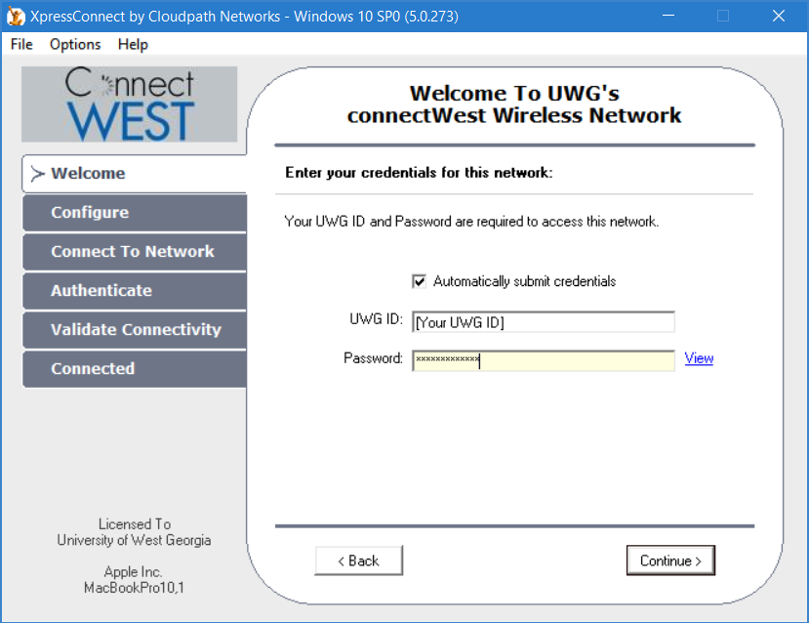

6. If you have entered your credentials correctly, the program will install the certificates and migrate you to the “connectWestSEC” network automatically.
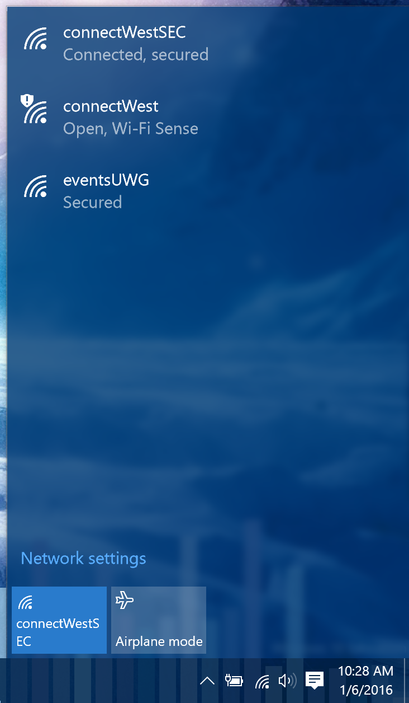
Congratulations! You are now connected to the UWG wireless network and should reconnect automatically whenever you are on campus.
You can now open your browser and surf the internet.
If you have any questions, please contact the Service Desk.

